#### - **Heap Memory**

* + Starts from the low memory values, grows up (opposite of Stack)
  + When the Heap meets the Stack, we are “out of memory”
  + Only create heap memory using keyword new:
    - allocates heap memory
    - calls the object’s constructor
    - returns a pointer to the memory
  + Only free heap memory using keyword delete:
    - calls the object’s destructor
    - marks memory as free
  + Delete the objects we created when we no longer use them
    - Heap memory is never automatically reclaimed
    - If we don’t free memory on heap, we are leaking memory. We cannot access it and we cannot reclaim it.
    - It’s a good practice to set deleted variable to NULL or nullptr. It’s a special value that means memory location “0”, and c++ throws an error if one tries to access it.

|  |  |
| --- | --- |
| heap1.cpp | |
| 1  2  3  4  5  6  7 | int main() {  int *p = new int; //pointer on stack, int on heap  Cube *c = new Cube(10);  //pointer on stack, object on heap  delete c; c = nullptr; //delete and set null  delete p; p = nullptr;  return 0;  } |

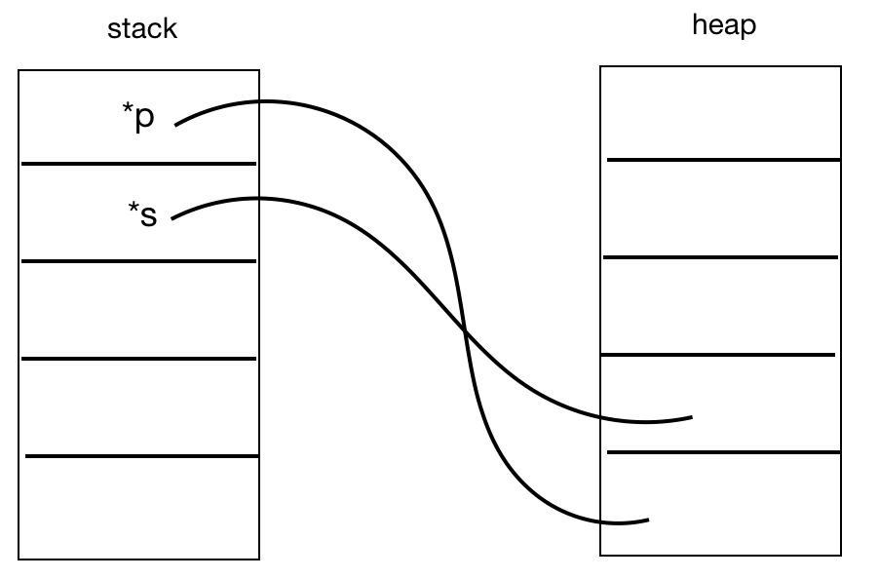

Fig. A stack pointer that points to heap memory blocks

|  |  |
| --- | --- |
| copy.cpp | |
| 1  2  3  4  5  6  7  8  9  10 | #include <iostream>  using std::cout;  using std::endl;  int main() {  int i = 2, j = 4, k = 8;  int *p = &i, *q = &j, *r = &k;  k = i;  cout << i << j << k << *p << *q << *r << endl;  // 2 4 2 2 4 2    p = q;  cout << i << j << k << *p << *q << *r << endl;  // 2 4 2 4 4 2  *q = *r;  cout << i << j << k << *p << *q << *r << endl;  // 2 2 2 2 2 2  } |

#### 

#### **Reference Variable**

* + Reference variable is an alias to an existing variable. It never creates new memory, and it needs to be initialized when declared, and it can never be redeclared.
  + When we modify the reference variable, that would also modify the variable being aliased.

|  |  |  |  |
| --- | --- | --- | --- |
| reference.cpp | | | |
| 1  2  3  4  5  6  7  8  9  10  11  12  13  14  15  16 | #include <iostream>  int main() {  int i = 7;  int & j = i; // j is an alias of i  j = 4;  std::cout << i << " " << j << std::endl;  // 4 4  // i and j are the same thing, they change together  i = 2;  std::cout << i << " " << j << std::endl;  // 2 2  return 0;  } | | |

#### **The use of “&” operator**

* + A declaration of a reference variable would be like:

|  |  |
| --- | --- |
| 1  2 | int a = 3  int & b = a; //declaring a reference variable |

* + However, this process should not be confused with the case of getting the memory address of a variable which would also involved with “&” operator, as the example shown below:

|  |  |
| --- | --- |
| 1  2 | Cube c;  std::cout << "Mem address storing c: " << &c << std::endl; |

#### Similarly, the use of “*” operator would also be either declaration of a pointer variable or the dereferencing of a variable’s to get its value. As we see more through cs225, we will have a better sense of knowing which context of situations that we are at.

horizontal line